**Topics: Normal distribution, Functions of Random Variables**

1. The time required for servicing transmissions is normally distributed with *μ* = 45 minutes and *σ* = 8 minutes. The service manager plans to have work begin on the transmission of a customer’s car 10 minutes after the car is dropped off and the customer is told that the car will be ready within 1 hour from drop-off. What is the probability that the service manager cannot meet his commitment?
2. 0.3875
3. 0.2676
4. 0.5
5. 0.6987

**ANS**: B is the right answer. The serving work will begin after 10 min of drop off so 45+10 which will now take more than the usual time so new mew is 55 minutes and the probability that it will take more than 1 hour to complete is 0.2659.



1. The current age (in years) of 400 clerical employees at an insurance claims processing center is normally distributed with mean *μ* = 38 and Standard deviation *σ* =6. For each statement below, please specify True/False. If false, briefly explain why.
2. More employees at the processing center are older than 44 than between 38 and 44.

**ANS**: False. Because the probability for employees at the processing center are more between 38 and 44 than older than 44.

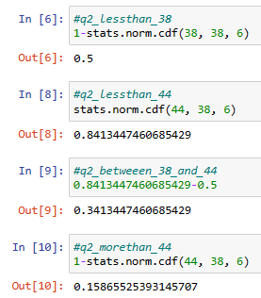

1. A training program for employees under the age of 30 at the center would be expected to attract about 36 employees.

**ANS**: True

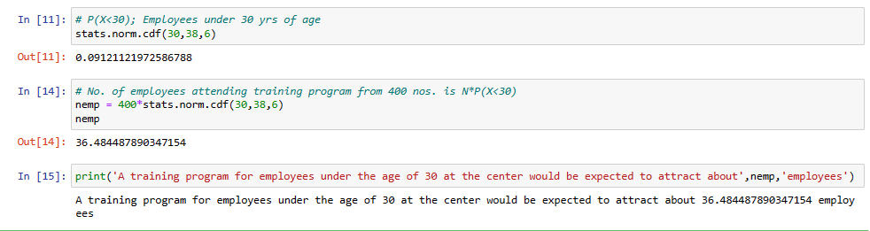

1. If *X1* ~ *N*(μ, σ2) and *X*2 ~ *N*(μ, σ2) are *iid* normal random variables, then what is the difference between 2 *X*1 and *X*1 + *X*2? Discuss both their distributions and parameters.

**ANS**: As we know that if X ∼ N(µ1, σ1^2 ), and Y ∼ N(µ2, σ2^2 ) are two independent random variables then X + Y ∼ N(µ1 + µ2, σ1^2 + σ2^2 ) , and X − Y ∼ N(µ1 − µ2, σ1^2 + σ2^2 ) .

Similarly if Z = aX + bY , where X and Y are as defined above, i.e Z is linear combination of X and Y , then Z ∼ N(aµ1 + bµ2, a^2σ1^2 + b^2σ2^2 ).

Therefore, in the question

2X1~ N(2 u,4 σ^2) and X1+X2 ~ N(µ + µ, σ^2 + σ^2 ) ~ N(2 u, 2σ^2 )

2X1-(X1+X2) = N(4µ,6 σ^2)

The Difference between 2X1 and (X1 + X2) is the magnitude they hold of two different sample subsets (X1 and X2) from the same source(population). X1 and X2 can be a different subset of a sample from a similar source (population). The distribution remains the same for every sample subset of similar source, it tends to fall under Normal distribution and slight deviations in parameters.

1. Let X ~ N(100, 202). Find two values, *a* and *b*, symmetric about the mean, such that the probability of the random variable taking a value between them is 0.99.
2. 90.5, 105.9
3. 80.2, 119.8
4. 22, 78
5. 48.5, 151.5
6. 90.1, 109.9
7. **ANS**: D -- 48.5, 151.5

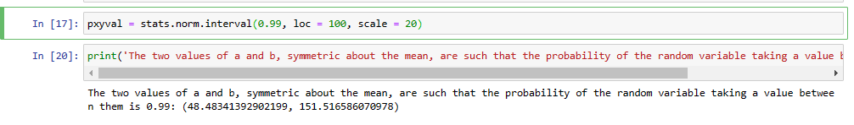

1. Consider a company that has two different divisions. The annual profits from the two divisions are independent and have distributions Profit1 ~ N(5, 32) and Profit2 ~ N(7, 42) respectively. Both the profits are in $ Million. Answer the following questions about the total profit of the company in Rupees. Assume that $1 = Rs. 45
2. Specify a Rupee range (centered on the mean) such that it contains 95% probability for the annual profit of the company.

**Ans**: Rupee ranges in between [9.9 to 98.1] Crore Rupees, 95% of the time for the Annual Profit of the Company.

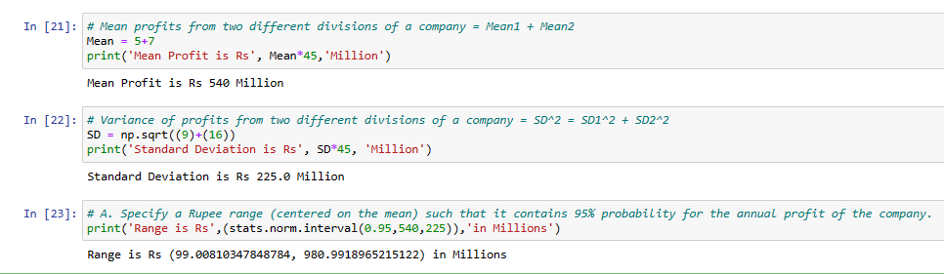

1. Specify the 5th percentile of profit (in Rupees) for the company

**Ans**: The 5TH Percentile of profit for the company is 17 Crore Rupees

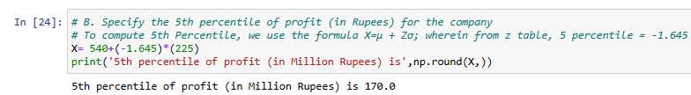

1. Which of the two divisions has a larger probability of making a loss in a given year?

**Ans**: The Division #1 (Profit1 ~ N(5, 32)) has a larger probability of making a loss in a given year